Subset of Azure Lab Services

* Provision Windows, Linux VMs in large batches across different environments (quickly spinup VMs for DEV, TEST)
* Install software on these VMs
* Manage configs
* Then publish VMs to users

Use cases

* Quickly deploy dev environments
  + Same for testers
* Load testing
* Training/classroom scenarios
  + Redeploy stuffs
  + Start VMs automatically when class hours start, then stop to save costs
* Self service deployments (no need for ops)
  + Policies can be set, AD stuffs, networking, etc
  + Build templates, share them, redeployments, etc
* Integrate with Azure DevOps

Reduces delays in creating and managing cloud infrastructure

Add Artifact(s) to VMs

Define Formulas (VM definition with predefined set of Artifcats as a recipe to describe a VM [reusable]) to provision many VMs quickly

# Deploy VM in DevTest

1. Image (from marketplace, or custom)
2. Define username, secret (DevTest can store these in secrets)
3. Set VM size
4. Set number to provision
5. Define networking (own vnet for DevTest?)
6. Access
   1. Public: every VM has public IP
   2. Private: remote access can be problematic
   3. Shared: use port numbers, same IP

# Artifacts

* Install tools, very specificly specify VM
* Great for application testing
* Clone repos
* **Actions**
  + Run scripts (bash, PowerShell) to config VM
* Config tasks
  + Networks to config, etc
* Mandatory Artifact
  + ‘this artifact HAS to be installed in VM’ as a policy
  + Eg. Security boundaries, etc

# Formulas

Custom image:

* Kinda hard to maintain, eg if we want to make a change:
  + deploy custom image
  + make changes
  + capture custom image
  + republish
* VM
* Then config
* Then install Apps

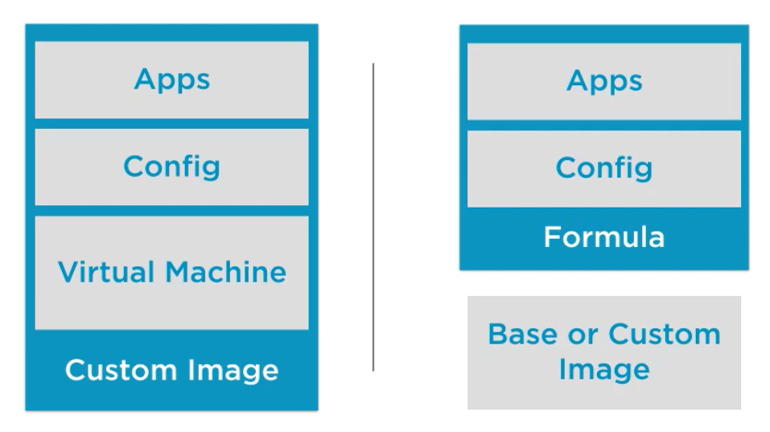

With formulas, decouple the maintenance of apps and config from VM (unlike Custom Image)

# Policies

* Auto startup, shutdown
* Number of VMs per lab or per user